Affiliated Club Agreement

iSightCornwall understands the importance of maintaining an active
social life, hobbies and interests to avoid feeling isolated and to stay independent. iSightCornwall supports 14 visually impaired clubs and groups across the county.

Affiliated Clubs operate independently and managed by volunteers who organise activities, outings, and entertainment and provide a friendly and caring environment for their members.

To support Affiliated Club, iSightCornwall will:
- Promote Club activities and membership
- Provide free Public Liability Insurance Policy for Club attendees
- Support Club Coordinators
- Resource and support Volunteers
- Provide free Employee Liability Policy for Volunteers
- Provide free DBS checks for Volunteers
- Provide a discretionary Transport Grant (reviewed annually)
- Explain club membership to new attendees

Employee Liability Policy for Volunteers
All volunteers assisting an Affiliated Club, whether club helper or driver must be registered with iSightCornwall. This will help pay compensation if a Volunteer is injured or becomes ill because of the work they do for an Affiliated Club.

* iSightCornwall can be fined £2,500 every day we are not properly insured.

Public Liability Insurance Policy for Club attendees
It is the responsibility of Club organisers to ensure that Public Liability Insurance covers attendees of the Club.

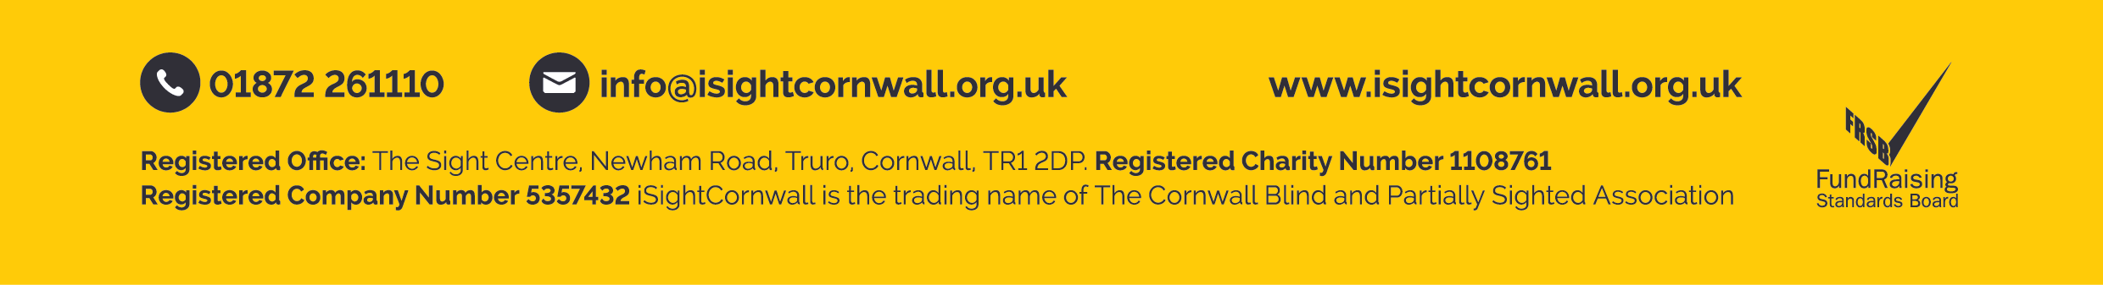
iSightCornwall provides free Public Liability Insurance as part of its Charity Membership scheme. Affiliated Clubs that do not follow this guideline must provide separate insurance and provide iSightCornwall with a copy of the Insurance Policy.

Transport Grant
Affiliated Clubs may apply for a grant to help subsidise transport costs, in line with our Transport Policy. Affiliated Clubs are responsible for administering the grant to cover Volunteer driver mileage costs for journeys to and from club activities. Applications for grants are made on an annual basis. The Transport Grant is a discretionary grant agreed annually by the Board of Trustees.

* Attendees that are not a Member of iSightCornwall will not be able to take advantage of the Transport Grant.

Affiliated Club organisers will:
- Ensure adequate Public Liability Insurance is provided – either via iSightCornwall or arranged separately
- Keep iSightCornwall informed of any changes to Volunteer helpers or drivers
- Inform iSightCornwall, on a 6 monthly basis, of the names of club attendees

12 December 2016

