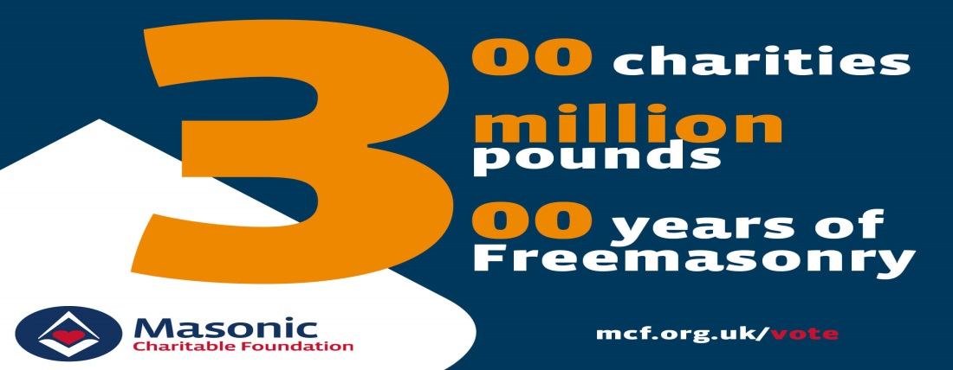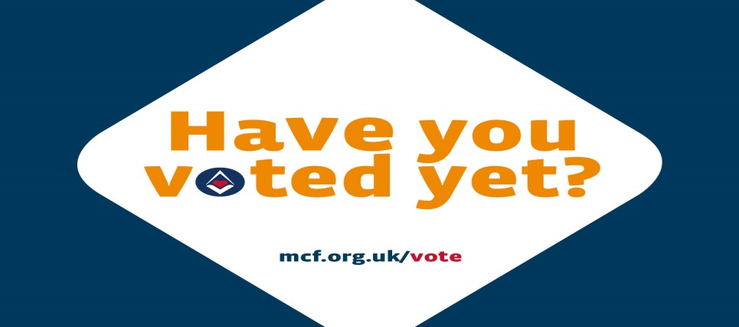
Province: ___Cornwall_________________
Charity: ___iSightCornwall____________

Name | Postcode | I am a Freemason | I am not a Freemason | Were you aware that Freemasons supported charities in this way? | Have the MCF Community Awards improved your opinion of Freemasonry?
 |  |  |  |  | My opinion was improved | My opinion has not changed | My opinion has worsened
Name | Postcode | I am a Freemason | I am not a Freemason | Were you aware that Freemasons supported charities in this way? | Have the MCF Community Awards improved your opinion of Freemasonry?
 |  |  |  |  | My opinion was improved | My opinion has not changed | My opinion has worsened
Name | Postcode | I am a Freemason | I am not a Freemason | Were you aware that Freemasons supported charities in this way? | Have the MCF Community Awards improved your opinion of Freemasonry?
 |  |  |  |  | My opinion was improved | My opinion has not changed | My opinion has worsened
Name | Postcode | I am a Freemason | I am not a Freemason | Were you aware that Freemasons supported charities in this way? | Have the MCF Community Awards improved your opinion of Freemasonry?
 |  |  |  |  | My opinion was improved | My opinion has not changed | My opinion has worsened

